show databases;

create database amarinsurence;

use amarinsurence;

create table person (driver_id varchar(10),

name varchar(20),

address varchar(30),

primary key(driver_id));

desc person;

create table car(reg_num varchar(10),model varchar(10),year int, primary key(reg_num));

desc car;

create table accident(report_num int, accident_date date, location varchar(20),primary

key(report_num));

desc accident;

create table owns(driver_id varchar(10),reg_num varchar(10),

primary key(driver_id, reg_num),

foreign key(driver_id) references person(driver_id),

foreign key(reg_num) references car(reg_num));

desc owns;

create table participated(driver_id varchar(10), reg_num varchar(10),

report_num int, damage_amount int,

primary key(driver_id, reg_num, report_num),

foreign key(driver_id) references person(driver_id),

foreign key(reg_num) references car(reg_num),

foreign key(report_num) references accident(report_num));

desc participated;

insert into person values("A01","richard","srinivas nagar"),

("A02","pradeep","rajaji nagar"),

("A03","smith","ashok nagar"),

("A04","venu","nk colony"),

("A05","john","hanuman nagar");

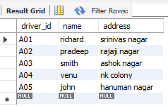

insert into car values("KA052250","Indica",1990),

("KA031181","Lancer",1957),

("KA095447","Toyota",1998),

("KA053408","Honda",2008),

("KA041702","Audi",2005);

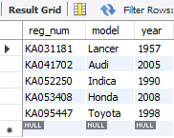

insert into accident values(11,"2003-01-01","Mysore Road"),

(12, "2004-02-02","Southend Circle"),

(13,"2003-01-21","Bulltemple Road"),

(14,"2008-02-17","Mysore Road"),

(15,"2005-03-04","Kanakpura Road");

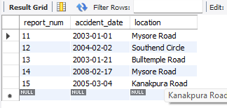

INSERT INTO owns VALUES("A01", "KA052250"),

("A02", "KA031181"),

("A03", "KA095447"),

("A04", "KA053408"),

("A05", "KA041702");

select * from owns;

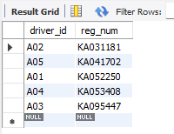

insert into participated values("A01","KA052250",11,10000),

("A02","KA053408",12,50000),

("A03","KA095447",13,25000),

("A04","KA031181",14,3000),

("A05","KA041702",15,5000);

select * from participated;

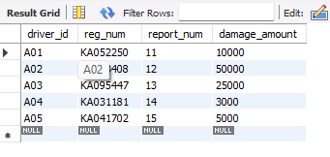

update participated

set damage_amount = 25000

where reg_num = 'KA053408' AND report_num = '12';

select * from participated;

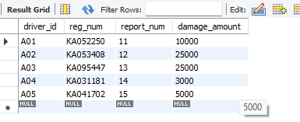

insert into accident values (16 , '2008-03-15','Domlur');

select * from accident;

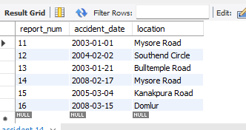

select * from car order by year asc;

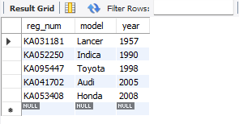

select count(report_num)

from car c, participated p

where c.reg_num=p.reg_num and c.model='Lancer';

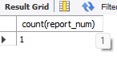

select count(distinct driver_id) CNT

from participated a, accident b

where a.report_num=b.report_num and b.accident_date like '__08%';

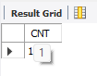

select * from participated order by damage_amount desc; 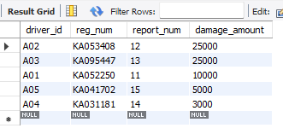

select avg(damage_amount) from participated;

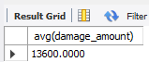

SELECT NAME FROM PERSON A, PARTICIPATED B WHERE A.DRIVER_ID = B.DRIVER_ID AND DAMAGE_AMOUNT>(SELECT AVG(DAMAGE_AMOUNT) FROM PARTICIPATED);



SELECT MAX(DAMAGE_AMOUNT) FROM PARTICIPATED;

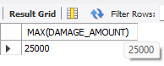

select accident_date , location from accident;

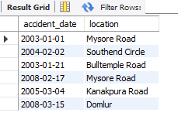

SELECT DISTINCT p.driver_id, p.name

FROM person p

JOIN participated pa ON p.driver_id = pa.driver_id

WHERE pa.damage_amount >= 25000;

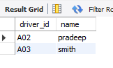

SELECT p.driver_id, p.name, c.reg_num, c.model

FROM person p

JOIN owns o ON p.driver_id = o.driver_id

JOIN car c ON o.reg_num = c.reg_num;

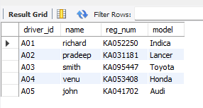

SELECT a.report_num, a.accident_date, a.location,

p.driver_id, p.name, pa.damage_amount

FROM accident a

JOIN participated pa ON a.report_num = pa.report_num

JOIN person p ON pa.driver_id = p.driver_id;

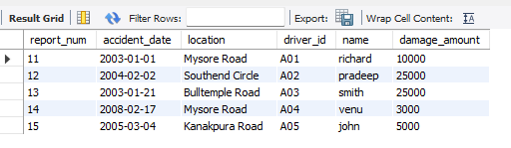

SELECT report_num, SUM(damage_amount) AS total_damage

FROM participated

GROUP BY report_num;

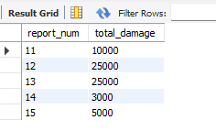

SELECT p.driver_id, p.name, COUNT(DISTINCT pa.report_num) AS accident_count

FROM person p

JOIN participated pa ON p.driver_id = pa.driver_id

GROUP BY p.driver_id, p.name

HAVING COUNT(DISTINCT pa.report_num) > 1;



SELECT c.reg_num, c.model

FROM car c

JOIN owns o ON c.reg_num = o.reg_num

WHERE c.reg_num NOT IN (

SELECT reg_num

FROM participated

);

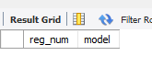

SELECT *

FROM accident

ORDER BY accident_date DESC

LIMIT 1;

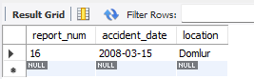

SELECT p.driver_id, p.name, AVG(pa.damage_amount) AS avg_damage

FROM person p

JOIN participated pa ON p.driver_id = pa.driver_id

GROUP BY p.driver_id, p.name;

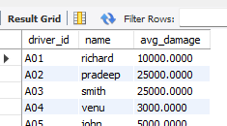

UPDATE participated

SET damage_amount = 25000

WHERE reg_num = 'KA052250' AND report_num = 11;

select * from participated;

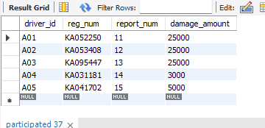

SELECT p.driver_id, p.name, pa.report_num, pa.damage_amount

FROM participated pa

JOIN person p ON pa.driver_id = p.driver_id

WHERE pa.damage_amount = (

SELECT MAX(damage_amount)

FROM participated

);

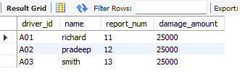

SELECT c.model, SUM(pa.damage_amount) AS total_damage

FROM car c

JOIN participated pa ON c.reg_num = pa.reg_num

GROUP BY c.model

HAVING SUM(pa.damage_amount) > 20000;

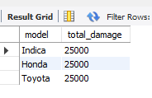

CREATE VIEW accident_summary1 AS

SELECT a.report_num, a.accident_date, a.location,

COUNT(pa.driver_id) AS participant_count,

SUM(pa.damage_amount) AS total_damage

FROM accident a

LEFT JOIN participated pa ON a.report_num = pa.report_num

GROUP BY a.report_num, a.accident_date, a.location;

select * from accident_summary1;

